**KONDREDDY SUMANTH KUMAR REDDY**

**QUESTION: 1**

**PROJECT 2: All deliverables should be kept in**

STEP 1: TSO ISPF

Create Physical sequential file as mentioned below NAME:

LRECL=80, RECFM=FB, BLKSIZE=29720

Manually input the following data into the

|  |  |  |  |  |
| --- | --- | --- | --- | --- |
| AGT NUMBER X (06) | AGT REG CD X (02) | BU X (15) | DIVISION X (05) | AGT SCORE 9 (03) |
| AG1000 | AR | PROPERTY | 00001 | 720 |
| AG2000 | AR | PROPERTY | 00001 | 690 |
| AX0017 | TX | VEHICLE | 00002 | 800 |
| AG0017 | AR | LIFE | 00001 | 740 |
| AG0175 | TX | LIFE | 00004 | 400 |
| AX0045 | TX | PET | 00002 | 400 |

STEP 3: COBOL PROGRAM

TYPE DSN DDNAME

PHYSICAL SEQUENTIAL INPUT USERID.TM01.AGENT.PS1 AGENTPS

Perform the following:

1. Validate the following fields
2. AGT NUMBER is greater than spaces
3. BU is greater than spaces
4. DIVISION is numeric and greater than zeros
5. Check the AGT SCORE
6. If AGT SCORE is less than 500.00 then set AGT STATUS as DORMANT
7. If AGT SCORE is greater than 500.00 then set AGT STATUS as ACTIVE
8. Write record into the output PS file with the following structure

AGT NUMBER | AGT REG CD | BU | DIVISION | AGT SCORE | AGT STATUS | FILLER X

(06) | X(02) | X(15) | X(05) | 9(03) | X(08) | X(34)

**INPUT:**

**INPUT FILE NAME: OZA142.TM01.AGENT.PS1**

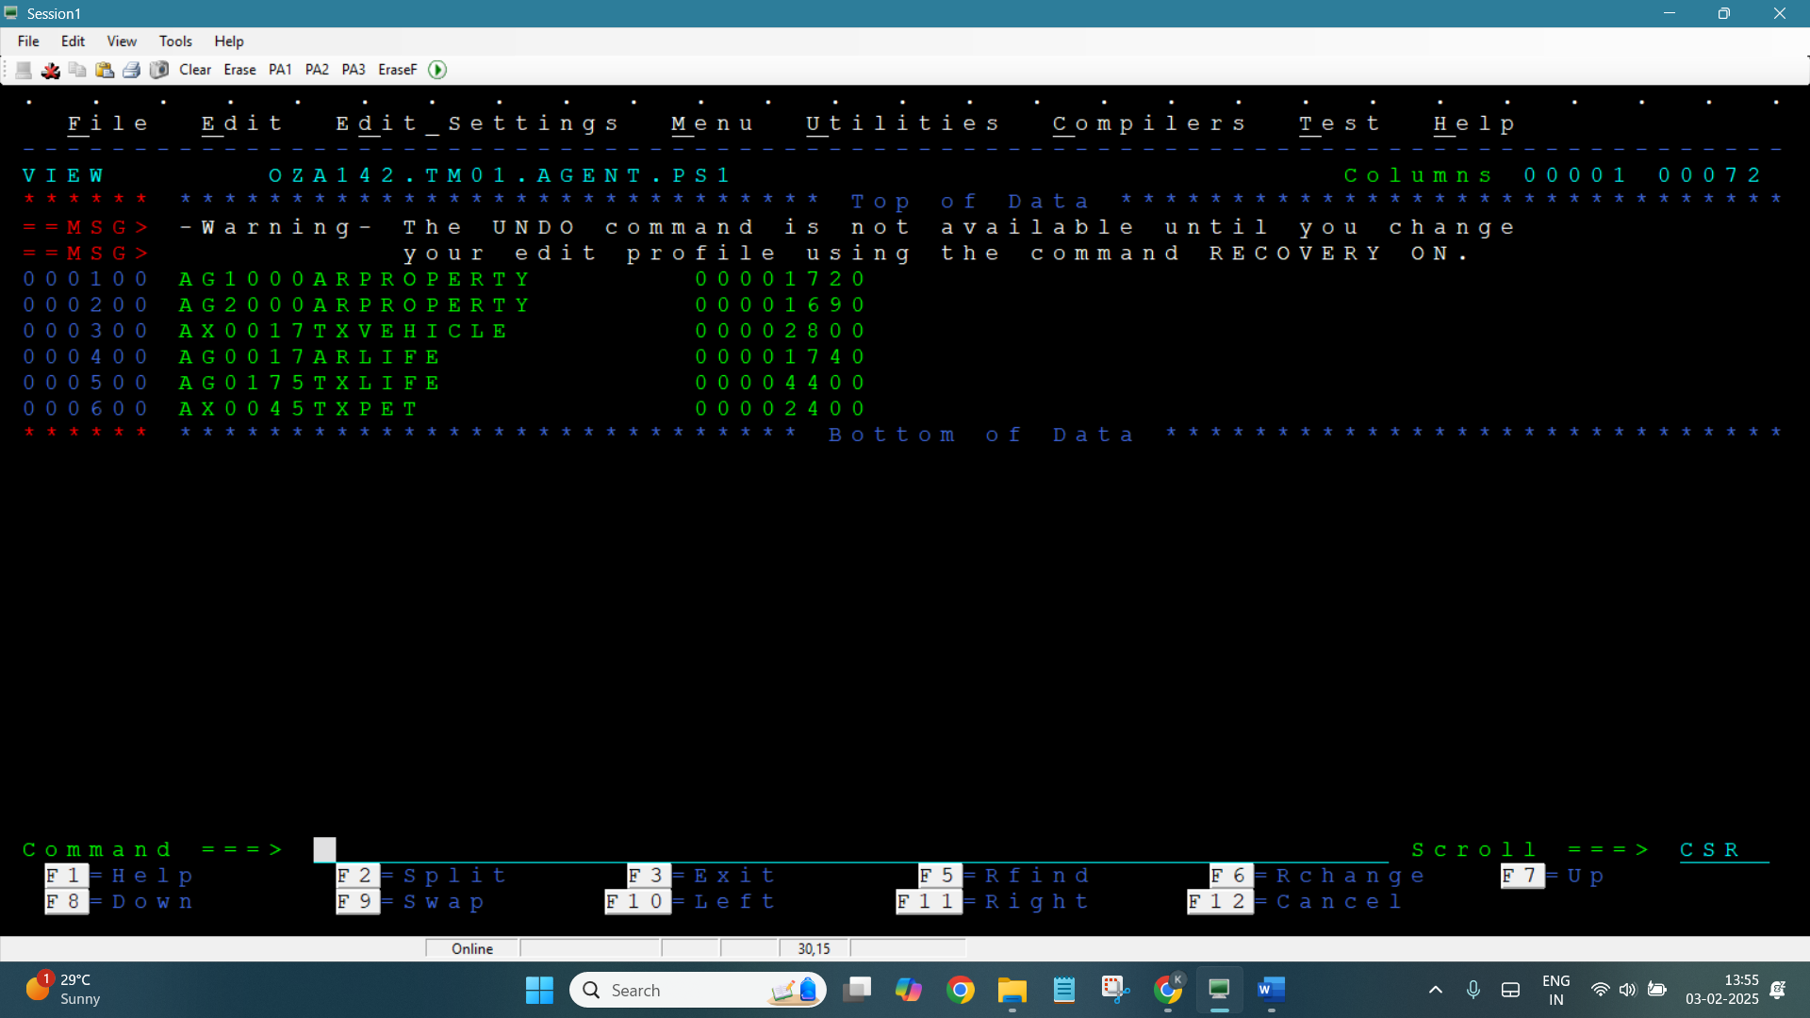

CODE:

**000100 IDENTIFICATION DIVISION.**

**000200 PROGRAM-ID. COB005.**

**000300 AUTHOR. SUMANTH.**

**000400**

**000500 ENVIRONMENT DIVISION.**

**000600 INPUT-OUTPUT SECTION.**

**000700 FILE-CONTROL.**

**000800 SELECT AGENTPS ASSIGN TO INP**

**000900 ORGANIZATION IS SEQUENTIAL**

**001000 ACCESS MODE IS SEQUENTIAL**

**001100 FILE STATUS IS WS-STATUS.**

**001200**

**001300 SELECT OUTPUTPS ASSIGN TO OUT**

**001400 ORGANIZATION IS SEQUENTIAL**

**001500 ACCESS MODE IS SEQUENTIAL**

**001600 FILE STATUS IS WS-STATUS.**

**001700**

**001800 DATA DIVISION.**

**001900 FILE SECTION.**

**002000**

**002100 FD AGENTPS**

**002110 RECORD CONTAINS 80 CHARACTERS**

**002120 BLOCK CONTAINS 27920 CHARACTERS**

**002130 RECORDING MODE IS F**

**002140 DATA RECORD IS AGENT-RECORD.**

**002200 01 AGENT-RECORD.**

**002300 05 AGT-NUMBER PIC X(06).**

**002400 05 AGT-REG-CD PIC X(02).**

**002500 05 BU PIC X(15).**

**002600 05 DIV PIC X(05).**

**002700 05 AGT-SCORE PIC 9(03).**

**002800 05 FILLER PIC X(49).**

**002810**

**002900 FD OUTPUTPS**

**002910 RECORD CONTAINS 80 CHARACTERS**

**002920 BLOCK CONTAINS 27920 CHARACTERS**

**002930 RECORDING MODE IS F**

**002940 DATA RECORD IS OUTPUT-RECORD.**

**003000 01 OUTPUT-RECORD.**

**003100 05 OUT-AGT-NUMBER PIC X(06).**

**003200 05 OUT-AGT-REG-CD PIC X(02).**

**003300 05 OUT-BU PIC X(15).**

**003400 05 OUT-DIVISION PIC X(05).**

**003500 05 OUT-AGT-SCORE PIC 9(03).**

**003600 05 OUT-AGT-STATUS PIC X(08).**

**003700 05 OUT-FILLER PIC X(34).**

**003800**

**003900 WORKING-STORAGE SECTION.**

**004000 01 WS-STATUS PIC X(02).**

**004100 01 WS-EOF PIC X(01) VALUE 'N'.**

**004200 88 END-OF-FILE VALUE 'Y'.**

**004300**

**004400 PROCEDURE DIVISION.**

**004500 BEGIN-PROCESS.**

**004600 OPEN INPUT AGENTPS.**

**004700 OPEN OUTPUT OUTPUTPS.**

**004800**

**004900 PERFORM READ-NEXT UNTIL END-OF-FILE.**

**005000**

**005100 CLOSE AGENTPS.**

**005200 CLOSE OUTPUTPS.**

**005300**

**005400 STOP RUN.**

**005500**

**005600 READ-NEXT.**

**005700 READ AGENTPS AT END**

**005800 SET END-OF-FILE TO TRUE**

**005900 NOT AT END**

**006000 PERFORM VALIDATE-RECORD.**

**006100**

**006200 VALIDATE-RECORD.**

**006300 IF AGT-NUMBER > SPACES AND BU > SPACES AND**

**006400 DIV IS NUMERIC AND DIV > ZEROS THEN**

**006500 PERFORM DETERMINE-STATUS**

**006600 ELSE**

**006700 DISPLAY 'INVALID RECORD IGNORED'.**

**006800**

**006900 DETERMINE-STATUS.**

**007000 MOVE AGT-NUMBER TO OUT-AGT-NUMBER.**

**007100 MOVE AGT-REG-CD TO OUT-AGT-REG-CD.**

**007200 MOVE BU TO OUT-BU.**

**007300 MOVE DIV TO OUT-DIVISION.**

**007400 MOVE AGT-SCORE TO OUT-AGT-SCORE.**

**007500**

**007600 IF AGT-SCORE < 500 THEN**

**007700 MOVE 'DORMANT' TO OUT-AGT-STATUS**

**007800 ELSE**

**007900 MOVE 'ACTIVE' TO OUT-AGT-STATUS.**

**008000**

**008100 WRITE OUTPUT-RECORD.**

**OUTPUT:**

